**Name: Wong Keng**

**Capstone Project 2: Snake Game**

**Game Filename:** *SnakeGame-WongKeng.html*

**Testing scenarios:**

It is recommended that the following tests be carried out for the Snake Game program:

1. **On execution of the snake game html file:**
   1. Ensure that the game loads successfully (see Figure 1).
   2. High score is correctly displayed
   3. ‘Play’, ‘Stop’ and ‘Pause’ buttons are displayed at the bottom of the canvas.
   4. Instruction to increase and decrease the game speed is shown below the 3 buttons described in Point 3.
   5. Image of a raptor is properly rendered on the canvas.

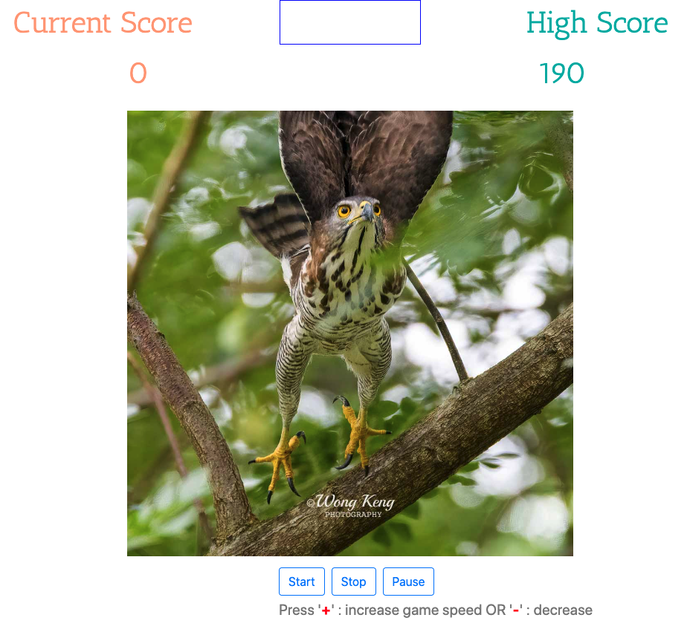

Figure 1

1. **On clicking the ‘Start’ button:**

With reference to Figure 2:

* 1. Check that the top centre Game Status shows ‘Play’ when game is started. The font colour of ‘Play’ should be Green.
  2. Check that game food and snake are displayed and snake starts to move across the canvas horizontally.
  3. Press the directional keys (Right, Left, Up and Down) on the keyboard and observe that the snake is responding correctly to these keys.
  4. Press the ‘+’ key on the keyboard and observe that the snake movement speeds up.
  5. Press the ‘-’ key on the keyboard and observe that the snake movement slows up.
  6. When the snake eats the food, check that 10 points are added to the Current Score for every food it consumes.
  7. Check that the High Score is updated accordingly if the Currently Score is higher than the displayed High Score. Take note of the high score.

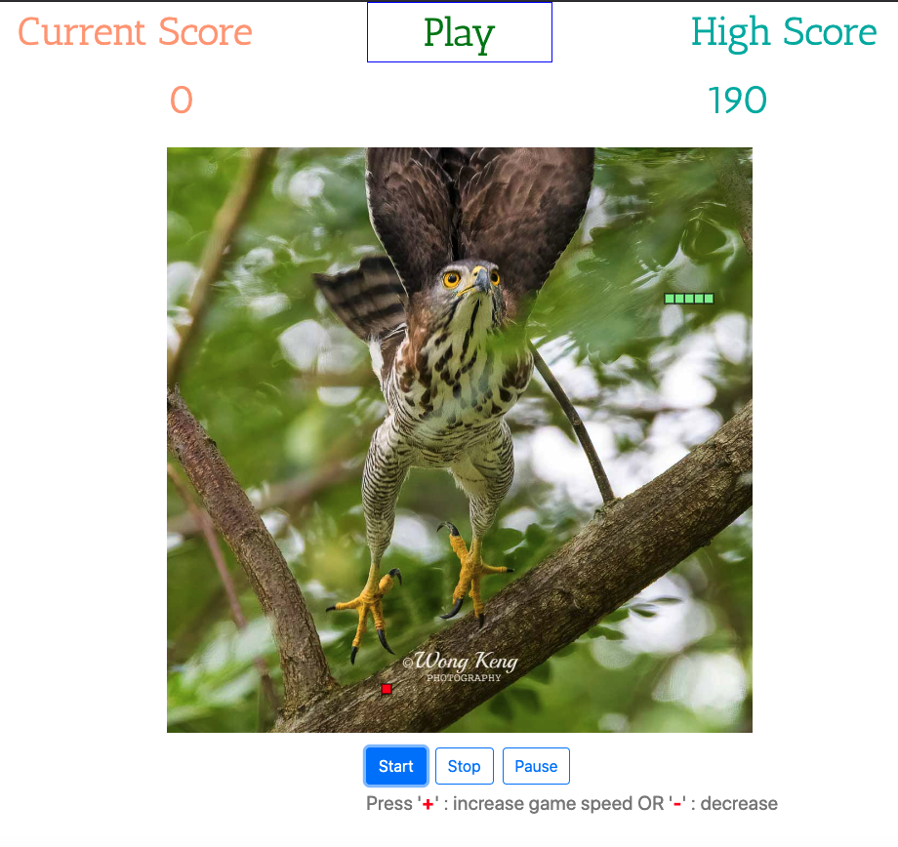

Figure 2

* 1. Refreshed or re-started the game and check that the High Score is correctly displayed.
  2. Let the snake hit the wall and observe that ‘Lose!’ is displayed on the Game Status. Its font colour should be Green (Figure 3)

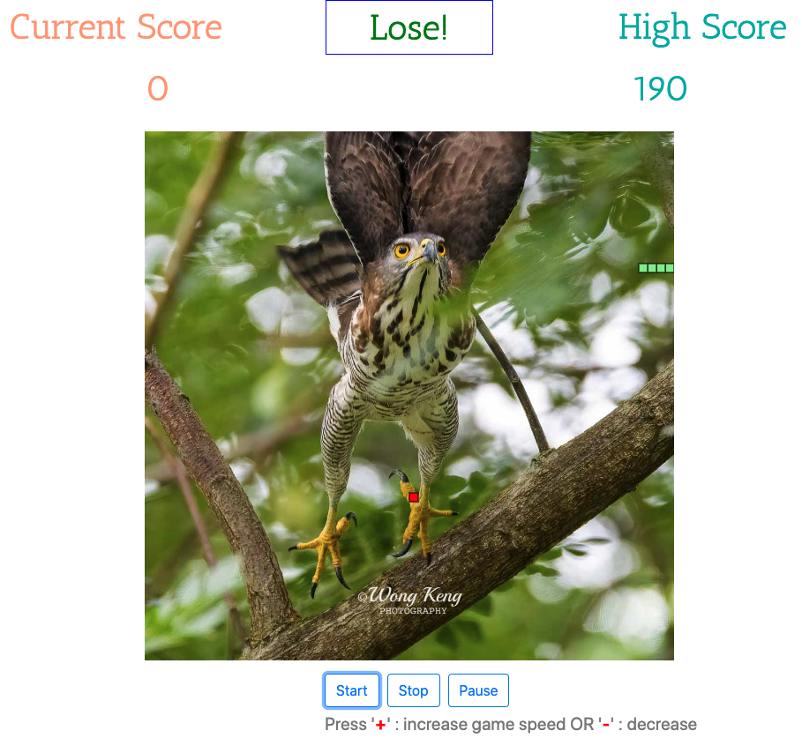

Figure 3

1. **On clicking the ‘Stop’ button:**

With reference to Figure 4:

* 1. Check that the top centre Game Status shows ‘Stop’ when game is stopped. The font colour of ‘Stop’ should be Red.
  2. Check that the snake movement is stopped. Use the directional keys to confirm that the snake does not respond to any of the 4 keys when they are pressed.
  3. Next, press the ‘Start’ button and take note of the starting point of the snake. It should start from the original starting position and not from where it stopped.
  4. ‘Play’ should be the displayed in the Game Status.
  5. Perform tests as in section “On clicking the ‘Start’ button:

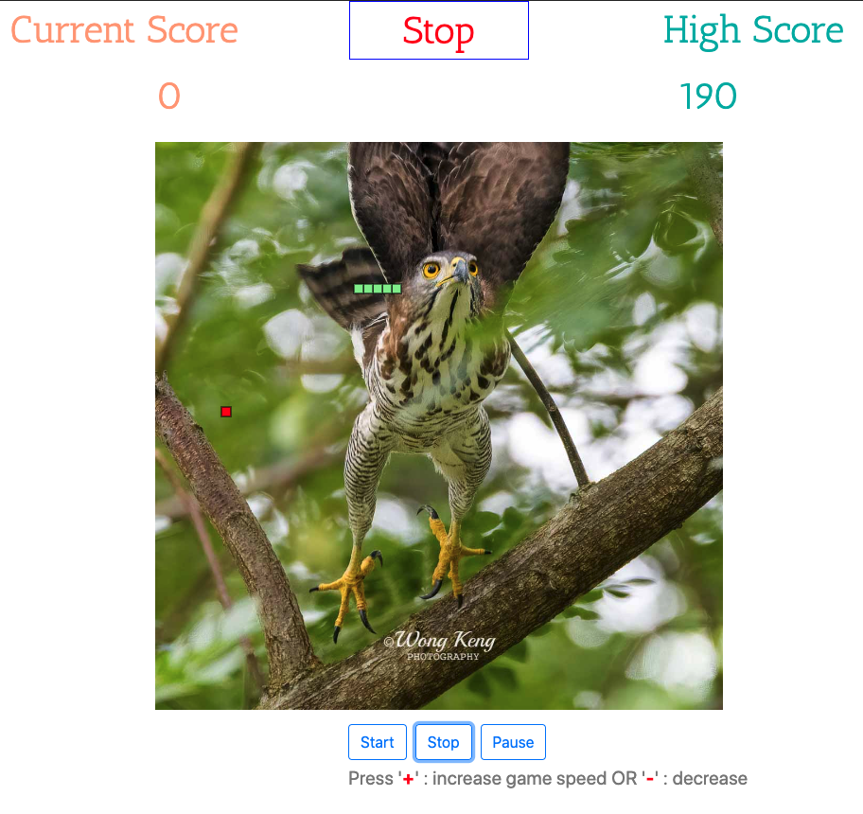

Figure 4

1. **On clicking the ‘Pause’ button:**

With reference to Figure 5:

* 1. Check that the top centre Game Status shows ‘Pause’ when game is paused. The font colour of ‘Pause’ should be Orange.
  2. Take note of the snake and food locations when the ‘Pause’ button is pressed.
  3. Check that the snake movement is paused. Use the directional keys to confirm that the snake does not respond to any of the 4 keys when they are pressed.
  4. Next, press the ‘Start’ button and observe that the snake will start from the current paused position. Also take note that the position of the food has not been changed. It should still be in its original position before the ‘Pause’ button was pressed.
  5. ‘Play’ should be the displayed in the Game Status.
  6. Perform tests as in section “On clicking the ‘Start’ button:

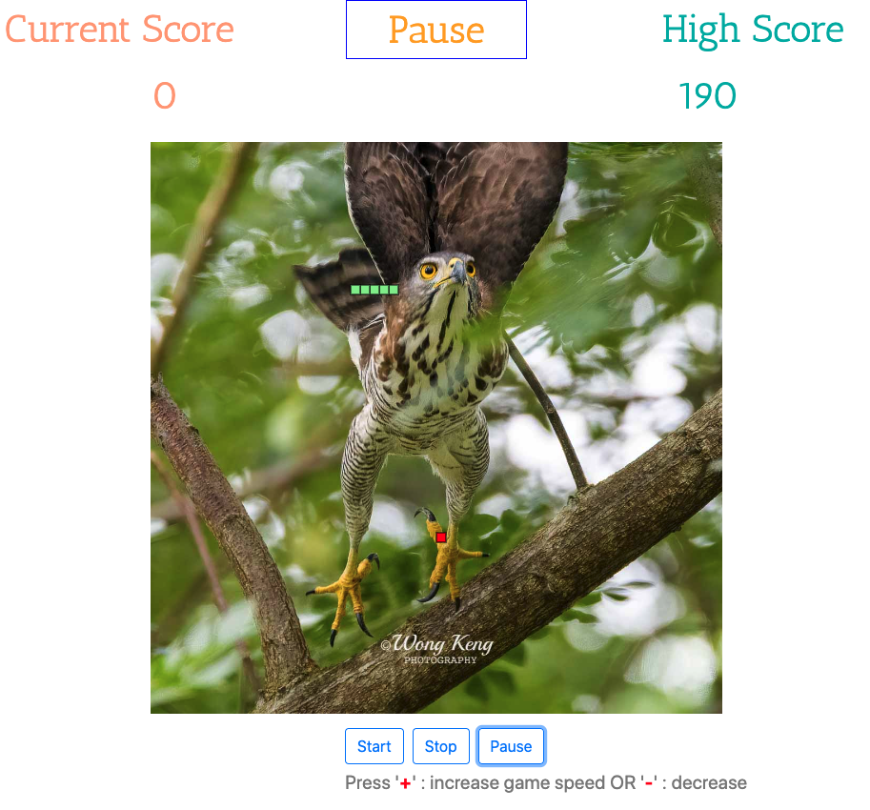

Figure 5

1. **Future Enhancements:**

Proposed future enhancements are as follows:

* 1. Random positioning of additional food, special food (these will give extra point and increase speed automatically).
  2. Random positioning of obstacles.
  3. Mouse-controlled movement of snake.
  4. Add option to use mouse or keyboard to control snake movement.
  5. Improve on the aesthetic of the game page; allow users to drag and drop new ‘skins’ on the canvas.
  6. Update to a better looking snake.